Squeegee Support New Style
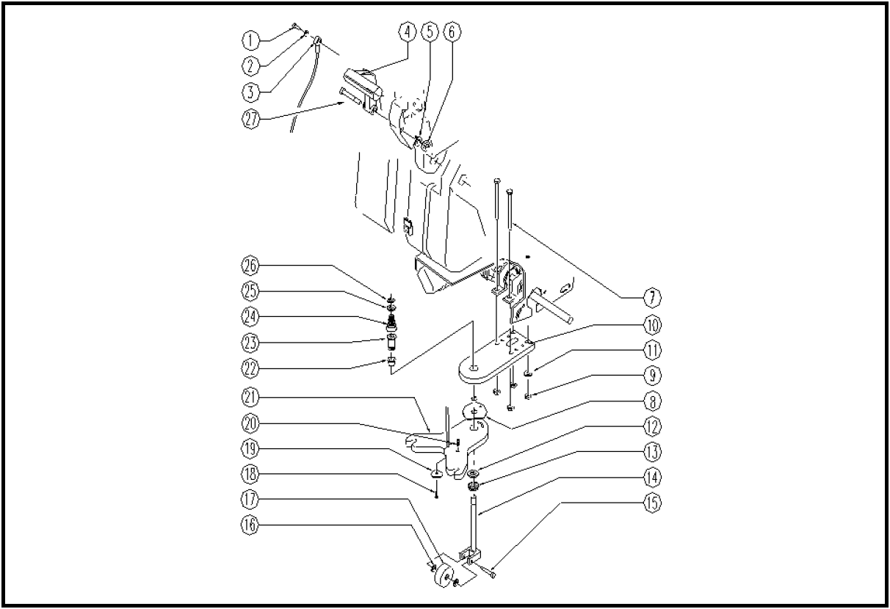
 | ITEM | SKU | DESCRIPTION | QTY | FROM
 | 1 | E88004 | Screw, Machine M4 x 12 | 1 | 05/2003
 | 2 | E89118 | Washer | 1 | 05/2003
 | 3 | E89462 | WS 24 Squeegee Cable | 1 | 09/2003
 | 4 | E89108 | Lever, Plastic Squeegee Lift | 1 | 05/2003
 | 5 | E88091 | Washer | 1 | 05/2003
 | 6 | E86462 | AS20 Nut | 1 | 10/2002
 | 7 | E89194 | Screw | 4 | 10/2002
 | 8 | VTRS00363 | WASHER D.6 | 1 | 03/2004
 | 9 | E86853 | Self-locking nut M8 | 4 | 05/2003
 | 10 | LAFN51070 | SQUEEGEE ARM | 1 | 03/2004
 | 11 | E86726 | Washer | 4 | 10/2002
 | 12 | VTRS00259 | RING | 1 | 04/2004
 | 13 | E87836 | Nut WS 24 | 1
 | 14 | E87872 | Support for WS20/24 | 1 | 10/2002
 | 15 | E87850 | Screw Squeegee Support | 1 | 04/2003
 | 16 | E86878 | Washer | 2 | 10/2002
 | 17 | E87845 | Red Wheel | 1 | 10/2002
 | 18 | E86578 | screw | 1 | 10/2002
 | 19 | E86577 | washer | 1 | 10/2002
 | 20 | E89195 | Screw | 1 | 07/2004
 | 21 | LAFN05555 | PLATE | 1 | 04/2004
 | 22 | E89403 | Bushing | 1 | 03/2004
 | 23 | E89405 | Pin | 1 | 03/2004
 | 24 | E89406 | Spring | 1 | 10/2002
 | 25 | E87873 | Washer for WS20 | 1 | 10/2002
 | 26 | E89408 | Stop Ring | 1 | 10/2002
 | 27 | E89217 | Squeegee handle bolt | 1 | 05/2003

